Linux Terminal commands:
1.$ uname
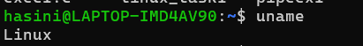

2.$ lscpu
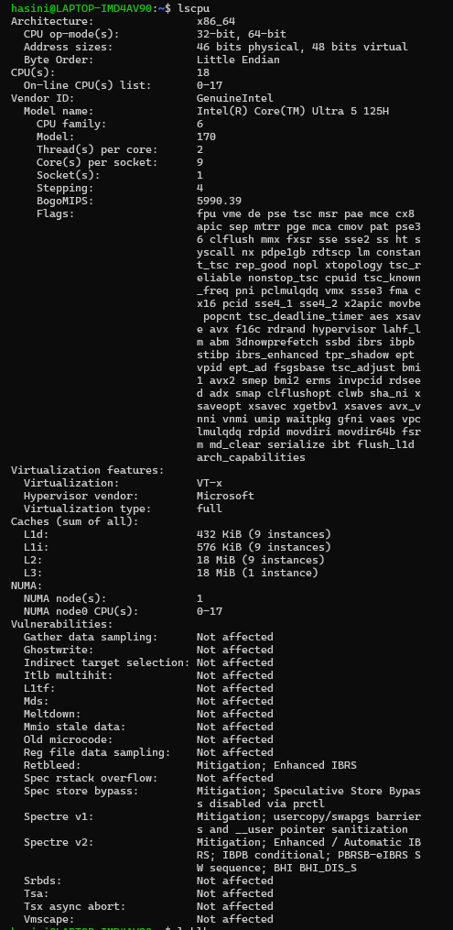

3.$ lsblk
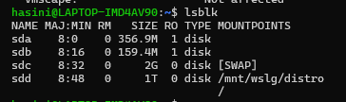

4.$ ps
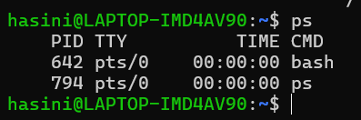

5.$ top
